**Networked Leadership Teams (NLT)**

**Who:**  All levels of management within ORD

**What:** Teams of 6-10 managers strategically populated with center directors, division directors, branch chiefs, associate directors, chiefs of staff, POS directors and IOAA leadership that results in the greatest level of connectivity within the organization. These types of teams have been referred to as a form of shared leadership that is relational, connected, and facilitates both bottom-up and a top-down collective engagement in addressing emergent issues.

**Why:**

* Tasked with creating the ORD of the Future that is Connected, Collaborative and Committed.
* Used to help prioritize organizational improvement focus areas and facilitate the successful implementation of the reorganization across ORD.
* Will coordinate with the various Communities of Practice who will facilitate more consistency in business and scientific operations and processes
* Provides mechanism for staff to provide input to a direct line supervisor that is networked to multiple levels of organization management.
* Create more leadership opportunities and increase the reach of new ideas and practices and allow for a corporate approach to improvements, implementation of ideas, and solutions to problems.

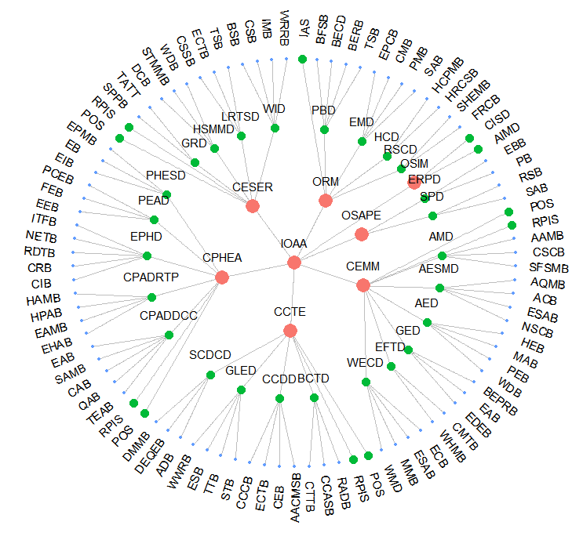**How:** One primary goal of the All Mangers Workshop is to build connections among managers and strengthen the overall ORD network within the new organization that will have managers changing roles and new management being hired. The new ORD can be illustrated in a network configuration in the following figure:

The concept is similar to the “six degrees from Kevin Bacon” game. However, since there are no Kevin Bacons in ORD, instead of trying to make everyone close to a single person, we will try to make everyone close to *everyone*, i.e. minimize the average distance. Using this network structure, the following can be seen – the most remote connections are those between branch chiefs in different office/centers, these have a distance of 6 in the network. All direct supervisory links are distance 1. The average distance of managers in the ORD network is shown above is 4.2. The goal is to create small-groups of managers to build connections in an informed way that lessens the average distance between all managers at ORD, and thus bringing everyone at ORD closer together.

**When:** The goal is to establish these networks by the end of August/early September and to have them convene in person at the All Managers Workshop in November. Monthly NLT meetings will be conducted to ensure cross-ORD connections and the successful corporate implementation of the reorganization. September and October NLT meetings will be focused on reviewing ORD’s vision and corporate expectations for managers.